Application Number | 07/2021/00841/FUL
Address | Land Opposite Ye Olde Hob Inn  Bamber Bridge  Preston  Lancashire  PR5 6EP
Applicant | South Ribble Borough Council - Regeneration Dept

Development | Regeneration of green space including erection of streel sculpture to commemorate the 'Battle of Bamber Bridge'
Officer Recommendation  Officer Name | Approval with Conditions  Mrs Debbie Roberts

Date application valid | 13.08.2021
Target Determination Date | 15.12.2021
Extension of Time | 15.11.2021

© Crown Copyright and database rights 2011 Ordnance Survey 100022485

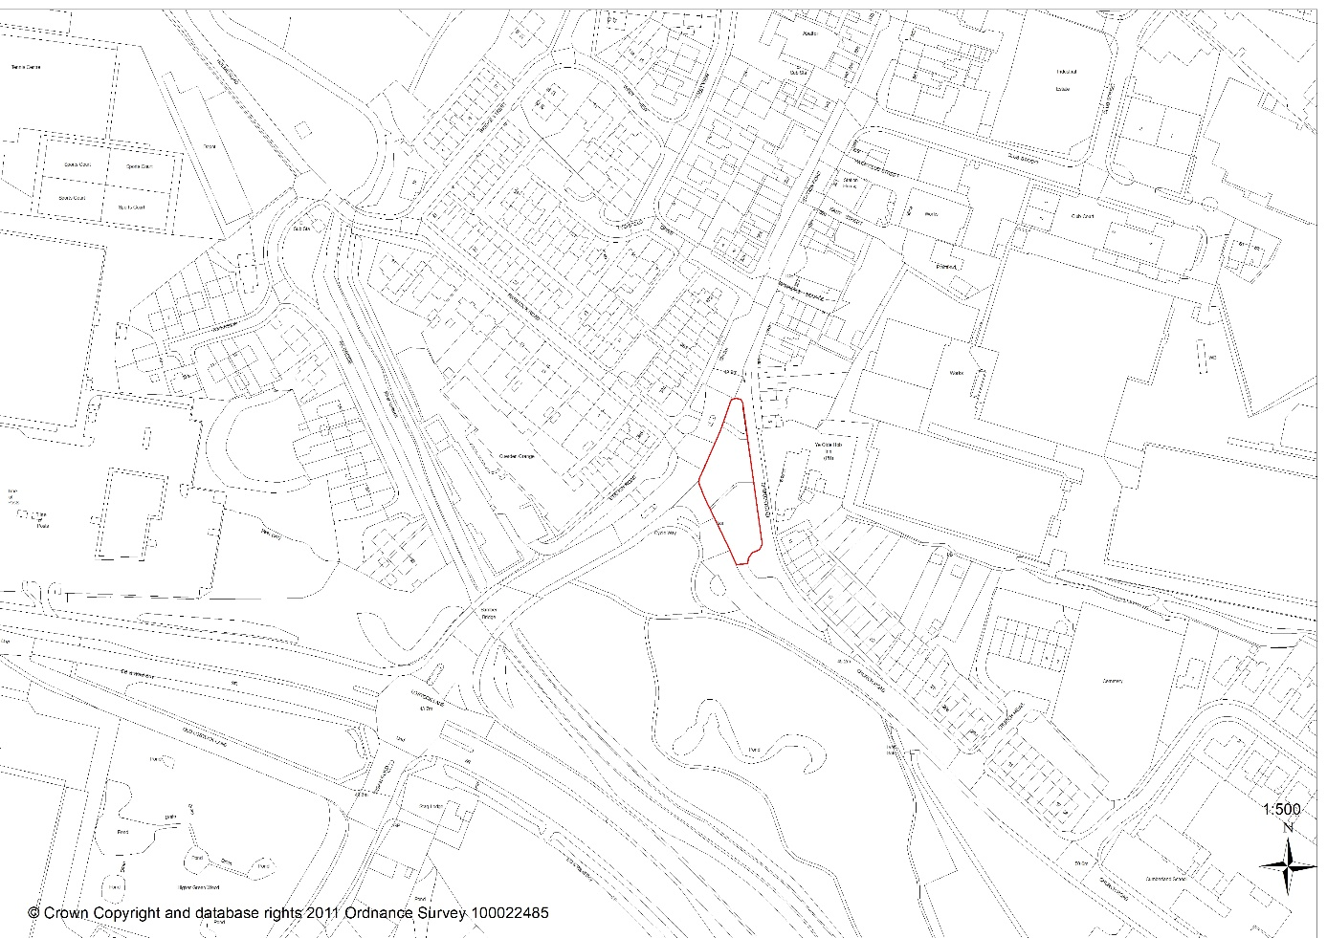

- Introduction

  - This application comes before Committee as the proposal is made by the Council’s Projects Team

- Report Summary

  - The application seeks permission for regeneration of land at the junction of Church and Station Roads, Bamber Bridge. The proposal as detailed in Section 5 (below) centres around celebration of the Battle of Bamber Bridge.

  - Representation was received from one resident in support, but who has concerns about tree protection. Approved plan REG-5529-02 however provides for tree retention as acceptable to the Councils Arborist and secured by tree protection condition. Comments from statutory consultees have been considered and conditions recommended where appropriate.

  - It is recommended that planning permission should be granted subject to the imposition of conditions

- Application Site and Surrounding Area

  - The application relates to the northern half of a piece of raised land /large grass verge located at the junction of Church and Station Roads, Bamber Bridge. The site is dissected by public footpaths, has mature trees and seating in its centre, and trees along the west and southern edges. A small BT Openreach box sits in the south-east corner.

  - The site is separated by an access road from Ye Olde Hob Inn public house (Grade II) and Church Road terraced dwellings (east). Grass verge extends in the south, and in the west is Church Road; beyond which is a similar, but larger tract of open land. The site and its surroundings are designated as Church Road Conservation Area.

- Site History
  - None relating directly to this piece of land

- Description of works

  - The application proposes regeneration of green space and erection of streel sculpture to commemorate the 'Battle of Bamber Bridge'.

  - Battle of Bamber Bridge - During the Second World War, Bamber Bridge hosted American servicemen from the 1511th Quartermaster Truck regiment. The 234th US Military Police Company was also located in the town, but US Armed Forces were racially segregated; soldiers of 1511th regiment being almost entirely African American, while most officers and MP’s were white. The people of Bamber Bridge supported the black troops, resisting segregation, and welcoming African American men who mingled freely with local white people. When American officers demanded a colour bar in the town, all three local pubs reportedly posted ‘Black Troops Only’ signs. On 24th June 1943 soldiers from the 1511th regiment were drinking with English troops and civilians in Ye Olde Hob Inn when passing MPs attempted to arrest one soldier; stating he was improperly dressed and without a valid pass. An argument ensued but as MPs left a beer was thrown at their jeep. MPs picked up reinforcements and intercepted the soldiers on Station Road prompting violent confrontation in which shots were fired and a black GI wounded. Rumours spread that MPs were shooting black soldiers; particularly as several jeeps full of MPs, and an improvised armoured car with a large machine gun arrived at the camp. This over-reaction prompted African American soldiers to arm themselves. A large group left the base, and what follows was a violent confrontation that led to stray bullets which entered houses, seven wounded and the death of Private William Crossland in the crossfire. A court martial convicted 32 African American soldiers of mutiny and related crimes. The American army remained segregated until 1948

  - The proposal – New pathways (tarmac or bonded resin - to be agreed) would connect the existing dissecting paths into a crescent shape. To the centre of the crescent would be a sculpture and information lectern, and benches and waste bins would be relocated to northern and southern ends. Trees would be retained and protected during construction. Ornamental landscaping is also proposed, and the BT box would be retained

  - Sculpture – A stainless, polished and galvanised steel, rectangular structure (2.4m x 1.3m) would be erected on fixed concrete pads. The frame would be engraved with ‘Bamber Bridge’ whilst the main structure would depict a Bamber Bridge skyline, Union Jack and USA national flags and the unit insignia of the 1511th Quartermaster Truck Regiment. Floor standing uplighters would be installed at the base of the sculpture.

- Summary of Supporting Documents

  - The application is accompanied by documents noted in proposed condition 2

- Representations

  - Site and newspaper advertisements were posted, and eleven neighbours individually consulted. Representation was provided by one resident who supports the scheme which will ‘improve the entrance to Bamber Bridge’. The same resident however is concerned that trees would be removed and that the site may be used as extra parking for users of the Hob Inn

  - Officer Note: Trees are to be retained and protected, and although there are parking issues on this stretch of Church Road, the site in question which sits between sections of highways is at a higher land level and banked steeply on the Church Road side. This and the general layout of the proposal should deter unauthorised parking.

- Summary of Responses

Lancashire County Council Highways – following a series of amended plans which now include mobility crossings, LCC have no objections.

  - South Ribble Arborist have no objections provided that the root protection level is not altered. There are no trees identified for removal, although an oak on the site edge would require work to its canopy. Trees in the immediate vicinity of works would be protected by condition during development.

  - South Ribble Environmental Health has no objections

- Material Considerations

  - Specific Policy Background

    - National Planning Policy Framework 2021: Chapter 16, Core Strategy Policy 16 (Heritage Assets) and Local Plan Policy G17 (Design) state that when considering proposed development of a designated heritage asset (including conservation areas and listed buildings), great weight should be given to the assets conservation, and to protecting and enhancing both the asset and its setting from inappropriate development.

    - The NPPF at Para 189 in particular states that ‘assets are an irreplaceable resource to be conserved in a manner appropriate to their significance, so that they can be enjoyed … for future and existing generations’

  - Other relevant policy

National Planning Policy Framework (2021)

    - Chapter 2 (Achieving Sustainable Development) includes a presumption towards sustainable development across a number of different objectives; one of which is a social role which includes ‘fostering well designed and safe environments … that reflect current and future needs and support communities’ health, social and cultural well-being’

Central Lancashire Core Strategy

    - Policy MP: states that applications which accord with the policies of the Local Plan will be approved without delay unless material considerations indicate otherwise.

    - Policy 17(Design of New Buildings) requires new development to take account of the character and appearance of the local area.

South Ribble Local Plan

    - Policies G13 (Trees, Woodland and Development) and G16 (Biodiversity and Nature Conservation) seek to protect and enhance the natural environment

    - Policy G17 (Design of New Buildings) attaches great importance to the design of the built environment, requiring proposals to take account of the character, appearance and amenity of the local area, and to highways and pedestrian safety

  - Character and Appearance, Impact upon Designated Heritage Assets and Relationship to Neighbouring Properties

    - Regeneration of the site will undoubtedly change its physical appearance, but not in such a distinct way that the proposal would impact negatively on the character or appearance of the conservation area or immediate locality. Existing seating will remain but will not be supplemented, and as such there would be no increased opportunity for anti-social behaviour. Proposed landscaping will be enhanced, and trees retained.

  - The proposal which is on land owned by the County Council will not affect or impact on the amenity of neighbouring residents. It will relate well to its surroundings and is considered to be appropriate in design and construction. As such it accords well to the National Planning Policy Framework, Core Strategy and South Ribble Local Plan, and is recommended for approval of planning permission consent subject to the imposition of conditions.

RECOMMENDATION:

Approval with Conditions.

RECOMMENDED CONDITIONS:

1. The development hereby permitted must be begun not later than the expiration of three years beginning with the date of this permission.
REASON: Required to be imposed pursuant to Section 91 of the Town and Country Planning Act 1990.

2. The development hereby permitted shall be carried out in accordance with the following approved documents
o Battle of Bamber Bridge information sheet
o Tree Survey (Ken Linford 15.7.21)
o Light specifications
o Site plan REG-5529-.02 (South Ribble)
o Location plan REG-5529-01 (South Ribble)
o New features plan REG-5529-04 (South Ribble)
o Spike lights specification REG-5529-05 (South Ribble)
o TP Path REG-5529-07 (South Ribble)
o New planting REG-5529-03 (South Ribble)
o Revised planting distances 5542-01
o Work area 5544-01
o Utilities location 5543.01

REASON: For the avoidance of doubt and to ensure a satisfactory standard of development in accordance with Policy 17 in the Central Lancashire Core Strategy and Policy G17 in the South Ribble Local Plan

3. No work shall be commenced until satisfactory details of the colour and texture of the facing and roofing materials to be used have been submitted to and approved by the Local Planning Authority.
REASON: To ensure the satisfactory detailed appearance of the development in accordance with Policy 17 in the Central Lancashire Core Strategy and Policy G17 in the South Ribble Local Plan 2012-2026

4. Prior to commencement of development, protective fencing should be erected around all trees to be retained within proximity of the approved development. The fencing shall consist of a scaffold framework in accordance with Figure 2 of BS 5837 - 2012 comprising a metal framework. Vertical tubes will be spaced at a maximum interval of 3m. Onto this, weldmesh panels shall be securely fixed with scaffold clamps. Weldmesh panels on rubber or concrete feet should not be used. The site manager or other suitably qualified appointed person will be responsible for inspecting the protective fencing daily; any damage to the fencing or breaches of the fenced area should be rectified immediately. The fencing will remain in place until completion of all site works and then only removed when all site traffic is removed from site.
reason: To protect trees from damage during construction in accordance with BS 5837 2012 in accordance with Local Plan Policy G13

5. No machinery shall be operated, no process carried out and no deliveries taken at or dispatched from the site where associated with construction, demolition or clearance of the site outside the following times:
0800 hrs to 1800 hrs Monday to Friday
0800 hrs to 1300 hrs Saturday
No activities shall take place on Sundays, Bank or Public Holidays.
REASON: To safeguard the living conditions of nearby residents particularly with regard to the effects of noise in accordance with Policy 17 in the Central Lancashire Core Strategy

6. No development shall take place, including any works of demolition, until a Construction Method Statement has been submitted to, and approved in writing by, the local planning authority. The approved Statement shall be adhered to throughout the construction period. The Statement shall provide for:
a) parking of vehicles of site operatives and visitors
b) loading and unloading of plant and materials
d) storage of plant and materials used in constructing the development
e) suitable wheel washing facilities for vehicles leaving site. Details also to include mechanical sweeping of roads adjacent to the site.
f) measures to control the emission of dust and dirt during construction
g) measures to control the emission of noise during construction
h) details of external lighting to be used during construction
i) a scheme for recycling/disposing of waste resulting from demolition and construction works
j) anticipated delivery times
REASON: To ensure before development commences that construction methods will safeguard the amenities of neighbouring properties in accordance with Policy 17 of the Central Lancashire Core Strategy and Local Plan 2012-2026 Policy G17

RELEVANT POLICY

NPPF National Planning Policy Framework

Central Lancashire Core Strategy
16 Heritage Assets
17 Design of New Buildings

South Ribble Local Plan 2012-2026
G13 Trees, Woodlands and Development
G17 Design Criteria for New Development

Note:

Other application Informative
1. Attention is drawn to the condition(s) attached to this planning permission. In order to discharge these conditions an Application for Approval of Details Reserved by Condition form must be submitted, together with details required by each condition imposed. The fee for such an application is £116. The forms can be found on South Ribble Borough Council's website www.southribble.gov.uk

2. The applicant is advised that under the terms of the Wildlife and Countryside Act 1981, Wild Mammal (Protection) Act 1996 and Countryside and Rights of Way Act 2000, it is an offence to disturb nesting birds, roosting birds or other protected species, or to inflict unnecessary suffering to wild animals. The work hereby granted does not override the statutory protection afforded to these species or provide defense against prosecution under this act, and you are advised to seek expert advice if you suspect that any aspect of the development would disturb any protected species

3. Highways Note: All works in the adopted highway to improve the existing paths must be completed in accord with a S144 License issued by LCC - Area West Highways Operations, or any form of highway agreement determined to be appropriate. The grant of planning permission will require the developer to obtain the appropriate permits to work on, or immediately adjacent to, the adopted highway network. The applicant should be advised to contact Lancashire County Council's Highways Regulation Team, who would need a minimum of 12 weeks' notice to arrange the necessary permits. They can be contacted on lhsstreetworks@lancashire.gov.uk or on 01772 533433.

